(Please complete the processing form in pen.)

School District Name_________________________________________________________ Date__________________________________________

Library Name_______________________________________________________________ Phone_________________________________________

Library Address_____________________________________________________________ Fax___________________________________________

City/State/Zip_______________________________________________________________ Sales Rep______________________________________

Contact_____________________________________________ E-mail _______________________________________________________________

*Yes No If we can not provide MARC Records for any books, should we ship those books?

Attached Packages
1.  Automation Processing (all materials attached)........................................................................................................................$.49 per title
(MARC Records, barcode label, and spine label set w/ protector)

2.  Automation Processing Plus Cards (all materials attached)......................................................................................................$.99 per title
(Catalog card set, MARC Records, barcode label, spine label set w/ protector)

3.  Full Processing (all materials attached).......................................................................................................................................$.89 per title
(Catalog card set, pocket, and checkout card, spine label set w/ protector)

Unattached Package
4.  Automation Processing (all materials unattached)...................................................................................................................$.45 per title
(MARC Records, barcode label, and spine label set)

5.  Catalog Card Kit (all materials unattached)..................................................................................................................................$.79 per title
(Catalog card set, pocket, checkout card, and spine label set)

CoLibri Book Covers
6.  Yes, protect my books with CoLibri Book Covers.................................................................................................................$1.10 per title

Individual Products
7. MARC Records....................................................................................................................................................$.20 per title
8. Checkout Card.....................................................................................................................................................$.15 per title
9. Catalog Card Set..................................................................................................................................................$.60 per title
10. Shelf List Card....................................................................................................................................................$.15 per title
11. Mylar on books with dust jackets........................................................................................................................$1.10 per title

Unattached Attached
12. Accelerated Reader Label………………………………………..…………………….………..$.25 per title..................................$.30 per title
13. Reading Counts Label………………………………………………………..…………………..$.25 per title..................................$.30 per title
14. Lexile Label…………………………………………………………………………………………$.25 per title..................................$.30 per title
15. Barcode Label *One per title Two per title………………………………………………$.10 per title..................................$.15 per title
16. Spine Label Set……………………………………………………………………………………$.15 per title..................................$.20 per title
17. Pocket……………………………………………………………………………………………...$.25 per title..................................$.30 per title
18. Pocket Label (Attached to bottom part of pocket)…………………………………………….$.20 per title..................................$.25 per title
19. Date Due Slips....................................................................................................................$.15 per title..................................$.20 per title
20. Theft Detection (choose one below)................................................................................$.45 per title..................................$.50 per title
    3M Tattle-Tape security strips Checkpoint (9.5 Frequency) Checkpoint (8.2 Frequency)

SECTION I: Cataloging Specifications

Call Number Options
Call Numbers: * Include call numbers  Don’t include call numbers
Capitalization: * Capitalize all main entry letters (ABC)  Capitalize first main entry letter only (Abc)

Classification Options
CATALOGING CLASSIFICATION OPTION NUMBERS OF MAIN ENTRY LETTERS
Non-Fiction: * Abridged Dewey * 3 Letters
 Unabridged Dewey  2 Letters
 Unabridged Dewey up to  1 Letter
__ digit(s) past decimal  No Letters
 Leave Classification Blank  Other______________________

Individual * 92 * 3 Letters
Biography:  921  B  2 Letters
 BIO  Bio  1 Letter
 Treat the same as Non-Fiction  No Letters
 Leave Classification Blank  Other______________________

Collective * 920 *  3 Letters
Biography:  92  CB  2 Letters
 BIO  Bio  1 Letter
 Treat the same as Non-Fiction  No Letters
 Leave Classification Blank  Other______________________

Fiction: * FIC *  3 Letters
 Fic  Fiction  2 Letters
 F  FICTION  1 Letter
 Leave Classification Blank  No Letters
 Other______________________

Story * SC * 3 Letters
Collection:  808.8  2 Letters
 808.83  1 Letter
 Treat the same as Fiction  No Letters
 Leave Classification Blank  Other______________________

Easy * E *  3 Letters
Fiction:  Easy  EASY  2 Letters
 Treat the same as Fiction  1 Letters
 Leave Classification Blank  No Letters
 Other______________________

Easy * E *  3 Letters
Non-Fiction:  Easy  EASY  2 Letters
 Treat the same as Non-Fiction  1 Letters
 Leave Classification Blank  No Letters
 Other______________________
 
Graphic Novels: * Treat the same as Non-Fiction (741.5) *  3 Letters
 Treat the same as Fiction  2 Letters
 Leave Classification Blank         1 Letters
 No Letters
 Other______________________
 

SECTION II: Barcode and Automation System Information

Automation Specifications

A. Software System: Athena Alexandria Dynix Follett Mandarin Sirsi Spectrum  Other_____________________

(Please contact your Software Company for more information)
B. Format: * ‘91 USMARC MicroLIF Protocol/MARC21 - 852 holdings (File Name: MicroLIF.001)
 ‘87 MicroLIF Protocol - 900 holdings (File Name: IBM.FIL)
 USMARC Communications – 949 holdings (File Name: Marc.001)

C. Send MARC Records by Email:_____________________________________________________________________

D. Library Name for Barcode Labels: (30 Characters Maximum Including Spaces)
|__|__|__|__|__|__|__|__|__|__|__|__|__|__|__|__|__|__|__|__|__|__|__|__|__|__|__|__|__|__|

E. Barcode Symbology: (Please contact your Software Company for more information)
*Code 3 of 9 (Code 39 or Follett Classic) Codabar with check digit (Provide a 13 digit barcode number)
Follett Interleaved 2 of 5 (T) Code 3 of 9-Mod 10 with check digit (Provide a 13 digit barcode number)                   Code 3 of 9-Mod 43 with check digit (Provide a 13 digit barcode number)
 

F. Barcode Number:
 Use next Barcode Number on File
 Barcode Number Range (Do not include check digit) ________________________________________________________
 Barcode Number Length ______________________
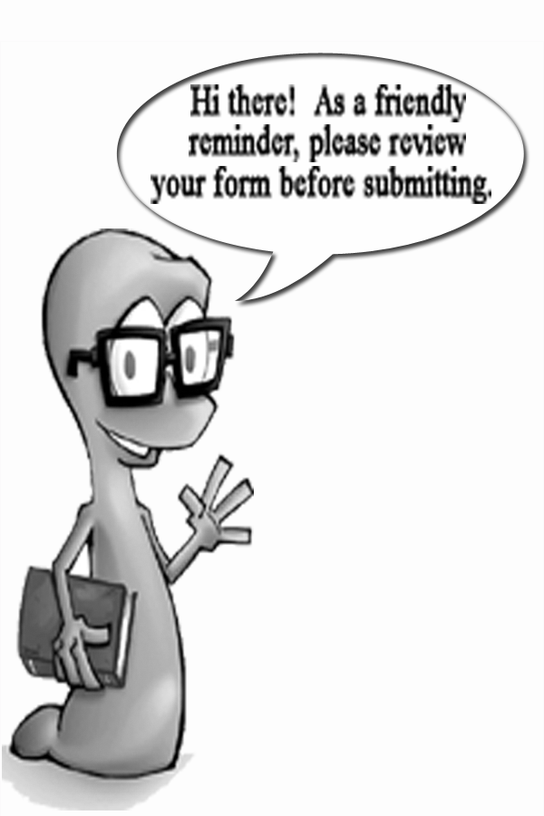

SECTION III: Processing Specifications

Book Specification Please check all applicable options below.

Spine Label Attached: *1” 1.5” 2” 2.5” Other________________________

Pockets Attached: * Inside Back Cover  Inside Front Cover  Back Flyleaf  Front Flyleaf None Other____________________

Date Due Slips Attached: * Inside Back Cover  Inside Front Cover  Back Flyleaf  Front Flyleaf
None Other____________________

Accelerated Reader Label Attached: * Above Spine Label  Inside Back Cover  Inside Front Cover
 Back Flyleaf  Front Flyleaf  Top Right  Top Left  Bottom Right  Bottom Left None Other____________________

Reading Counts Label Attached: * Above Spine Label  Inside Back Cover  Inside Front Cover
 Back Flyleaf  Front Flyleaf  Top Right  Top Left  Bottom Right  Bottom Left None Other____________________

Lexile Label Attached: * Above Spine Label  Inside Back Cover  Inside Front Cover
 Back Flyleaf  Front Flyleaf  Top Right  Top Left  Bottom Right  Bottom Left None Other____________________

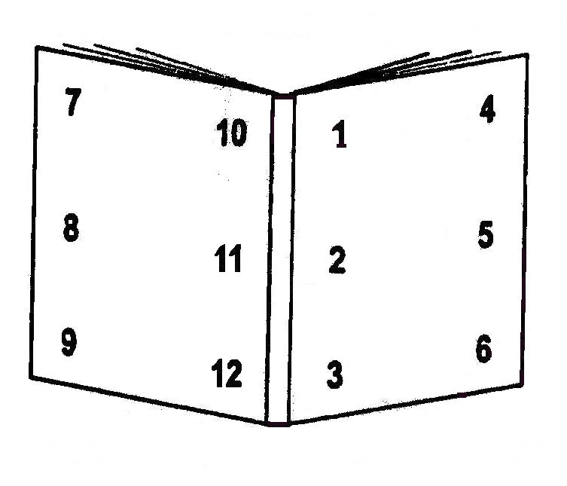
Barcode Label Attached: Location: Position of Barcode Label:
 1  7 * Horizontal (perpendicular to spine)
 2  8  Vertical (parallel to spine, reading up)
 3  9  Vertical (parallel to spine, reading down)
 4 * 10  Other________________________
 5  11
 6  12

Outside Back Cover Outside Front Cover

Attach 2nd Barcode Label - -  Yes OR  No
***If yes, please select Location and Position below or the barcode label will be sent unattached.***

Barcode Label Attached: Location: Position of Barcode Label:
* 1  7 * Horizontal (perpendicular to spine)
 2  8  Vertical (parallel to spine, reading up)
 3  9  Vertical (parallel to spine, reading down)
 4  10  Other________________________
 5  11
 6  12

Outside Back Cover Outside Front Cover

